**Experiment 10**

*Aim:* Design an attractive Login and Registration form using Material-UI. Use

Validations to validate the errors and prompt the errors on the webpage

1. In components folder, make Signup*.js,* and design the Registration page -

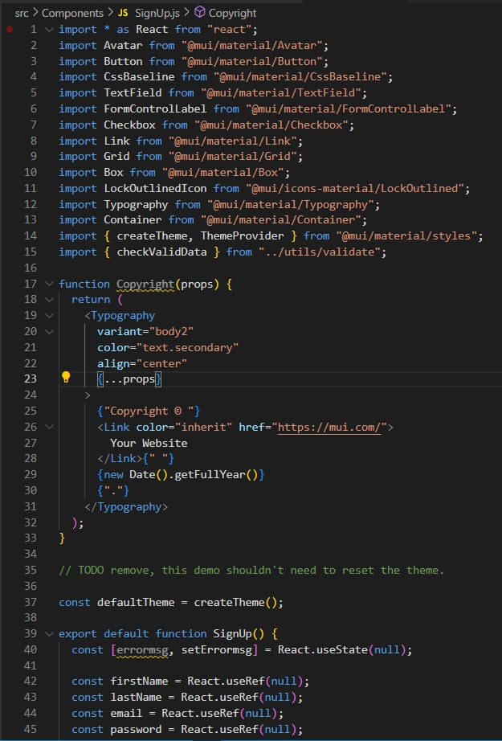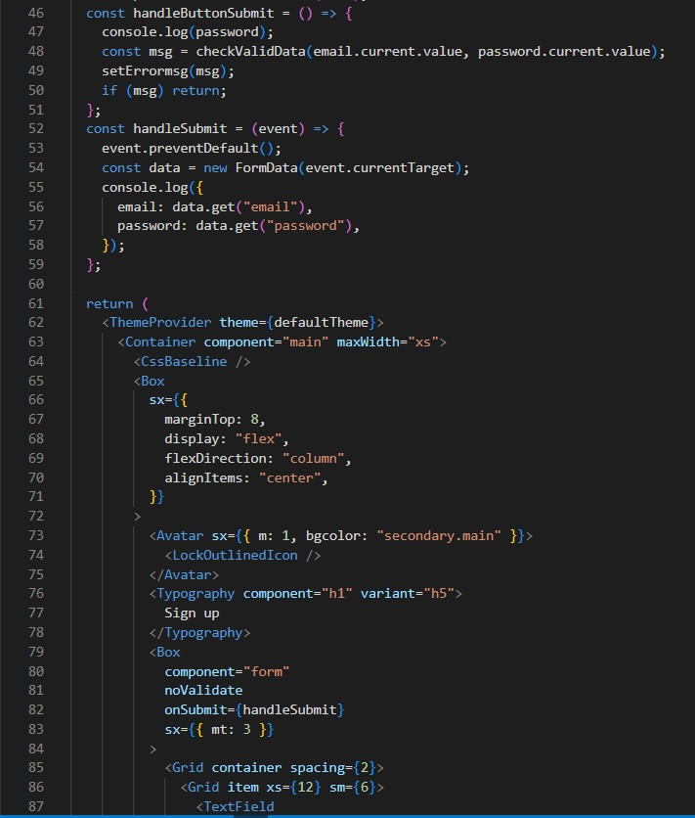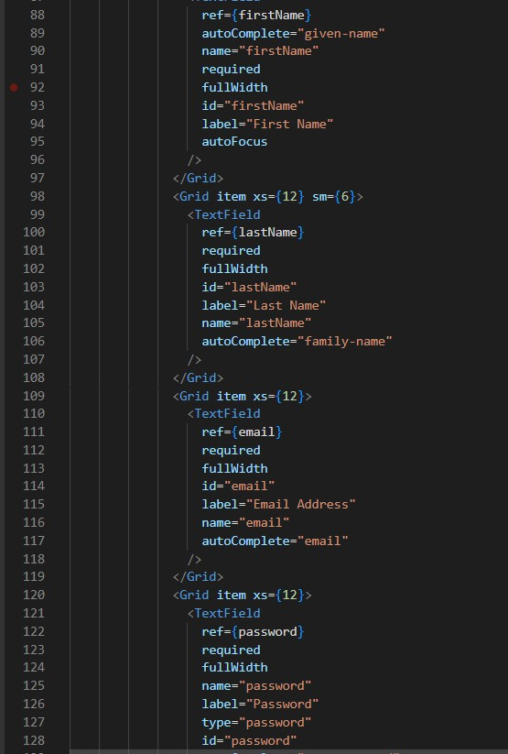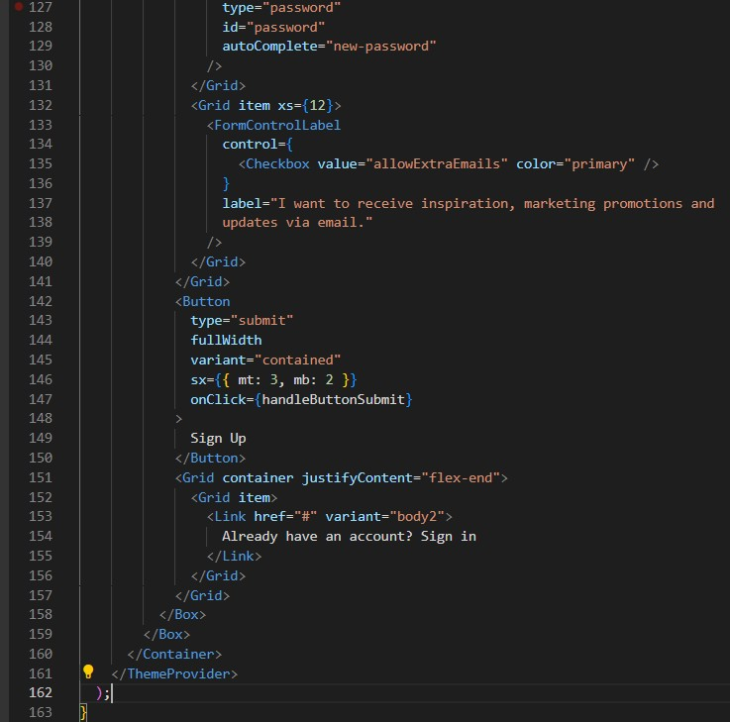

1. Make the login page

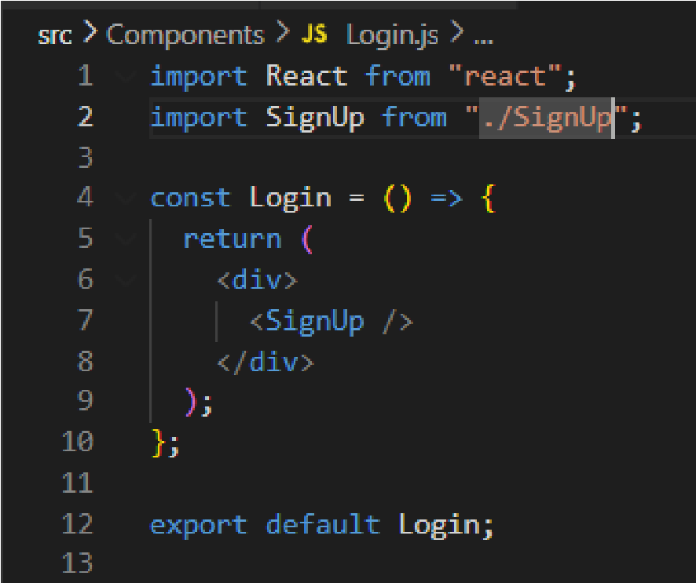

1. Adding a validation feature to check the inputs of the user

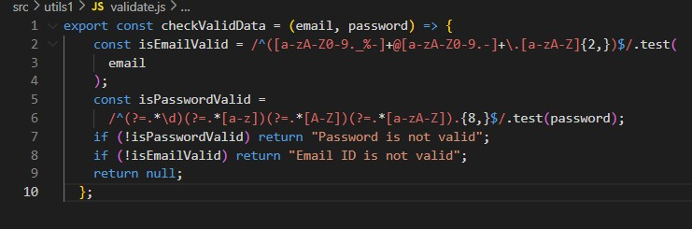

1. Update the *App.js*

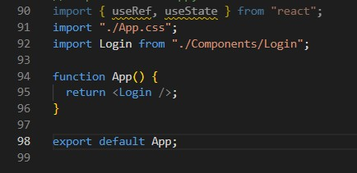



**OUTPUT**

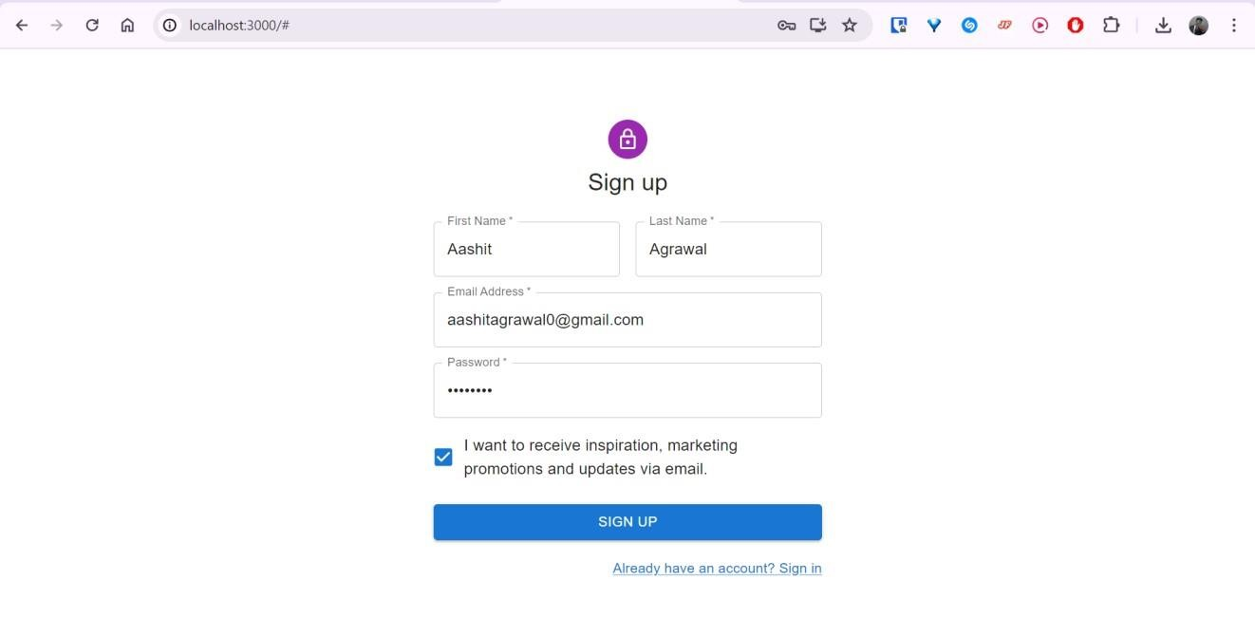

**Discussions:**

This experiment explores the integration of Material-UI components for aesthetically pleasing login and registration forms while implementing validation to provide realtime error feedback.